Source name | Priority  (High/Medium/Low) | Known format challenges (e.g., scanned PDF, Requires Login, Lack of API) | Result
Government Gazette (www.et.gr) | Y | PDF | We can find the laws, but themselves are not translatable
Websites of ministries (ypergasias.gov.gr) ypen.gov.gr | Y |  | Site only in Greek, no site translation disponible
Diavgeia (diavgeia.gov.gr) | M |  | It is possible to translate the main site, but the sites under the menus are not
EUR-Lex (eur-lex.europa.eu) | Y | PDF | Site where the EU legislation can be found, there is versioning of the laws.
European sites (cen /cenelec) –(www.cencenelec.eu) | Y |  | This shows the standards, but there’s no free download
ELINYAE | Y | PDF | Only gives us an e-mail to reach out if we want the documentation  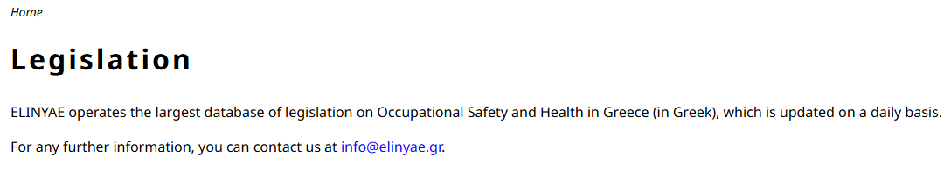
P.Y. (fireservice.gr) | Y |  | Site only in Greek, no site translation disponible
RAAEY | M |  | Possible to translate the main site, but the sites under the menus are not.

